# 

***STUDENT PORTFOLIO***



Name: Nandini

Reg. No.: RA2011031010003

E-Mail ID: nq8714@srmist.edu.in

Department: CSE

Specialization: IT

Semester: V

**Subject title**:

18CSC302J Computer Networks

**RECORD FILE**

[**https://drive.google.com/file/d/1bsz4Qi30y9V76v_7uJr7xxOu03aW_vY5/view?usp=sharing**](https://drive.google.com/file/d/1bsz4Qi30y9V76v_7uJr7xxOu03aW_vY5/view?usp=sharing)

**MINI PROJECT FILE**

[**https://drive.google.com/drive/folders/1kbXkLFP2BUpdGPLQZ9I7chVJabcGXZRu?usp=sharing**](https://drive.google.com/drive/folders/1kbXkLFP2BUpdGPLQZ9I7chVJabcGXZRu?usp=sharing)

**AWS COURSE CERTIFICATE AND BADGE**



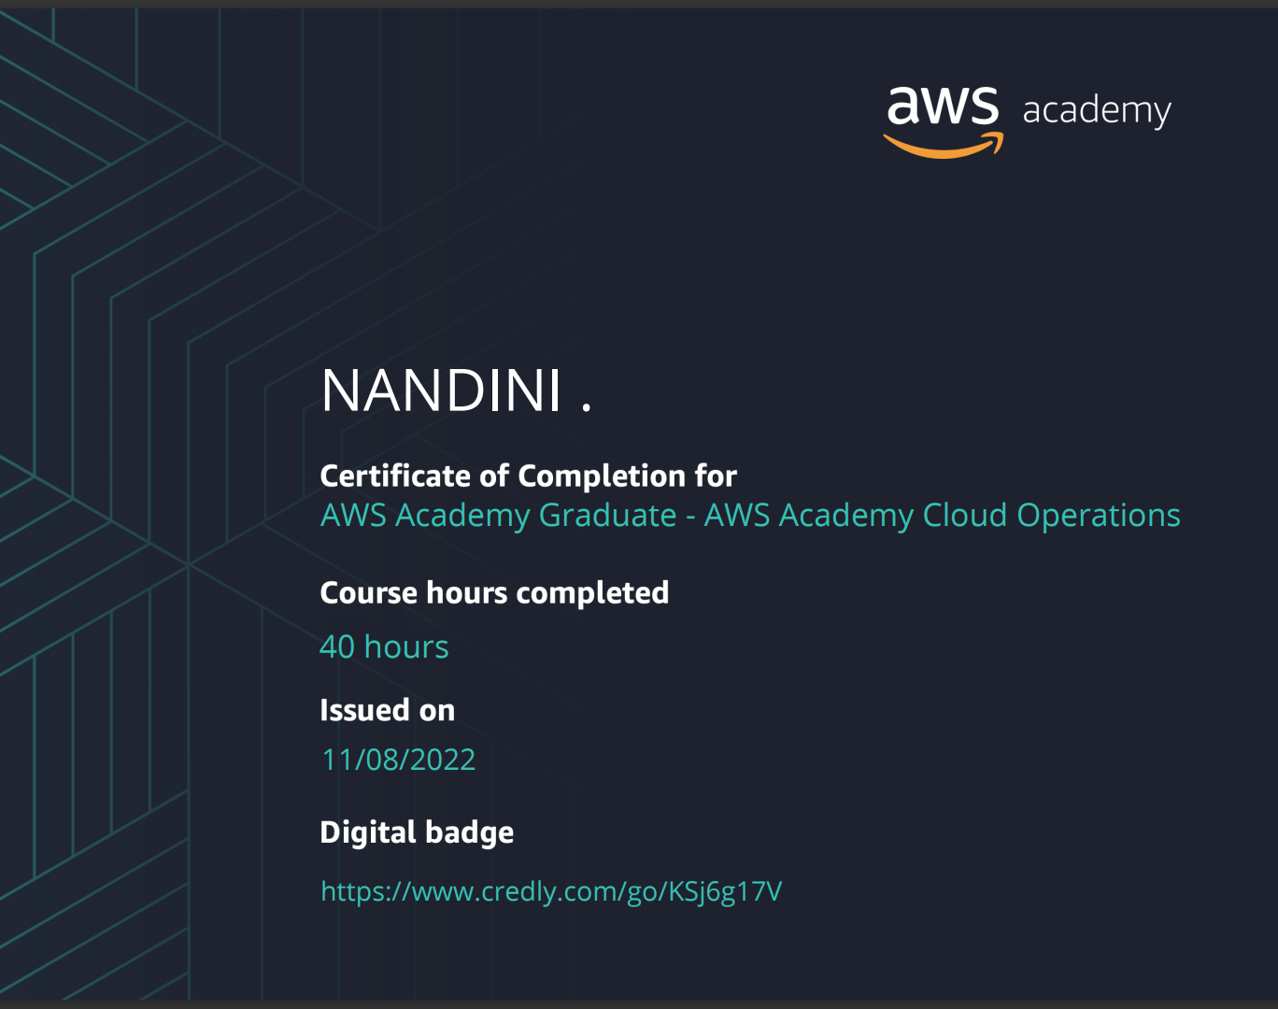

# **Hackerank Certificate**

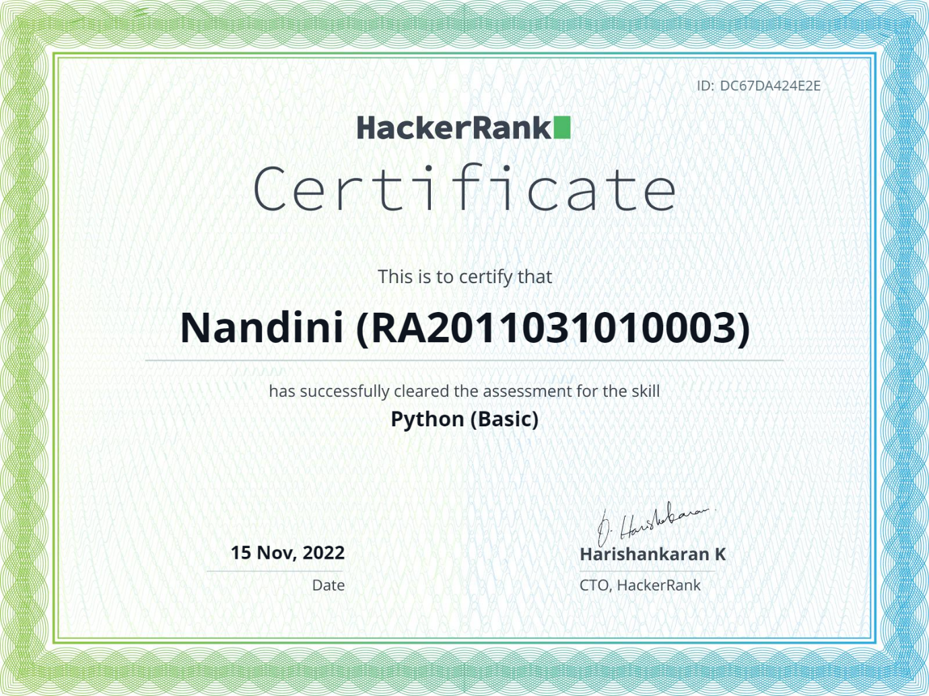

**MOOC Certificate**

# 